The Combine
14908 County Road 79
Elk River, MN 55330
(763) 312-6102

Please enjoy your workout with nature.
Please also help me keep everyone (from the squirrels to the neighbors) happy.

- Stay on the trail. If you do elect to get off trail, please welcome yourself to the poison ivy.
- Stay away and out of buildings. They are haunted.
- While frequent safety/equipment checks occur, please be wise, if something is damaged do not use it and notify the instructor.
- Do not harass the wildlife. If you mess with the small animals, the bears will eat you.
- Positive words of encouragement are welcome, but please be considerate to the neighbors. Avoid any profanity, music (personal ok), or unnecessary screaming.
- Remove any waste. Unless you puke…you can keep that on the course (but that will attract Bigfoot-see last rule).
- No unauthorized vehicles on the course.
- No alcohol, tobacco, or illegal firearms. Normally they mix well, but just not here.
- I recommend a well-fitting work gloves on some obstacles for additional grip/protection.
- If there are any issues, concerns, suggestions, donations, and/or Bigfoot sighting (in which you survive) please do not hesitate to contact me.
- Be aware of Bigfoot….and whatever you do, do not make eye contact.
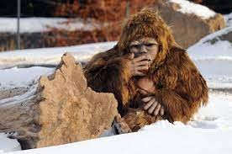

In case of emergency call 911.
Address: 14908 County Road 79
Elk River, MN 55330

Have another participate meet EMS at the road to help direct back to the appropriate area.
There is an alternative route as noted on the map for authorized/emergency vehicles.

